Day-03 API Integration Report

Fetching Data from Sanity API in a Next.js Project

Introduction:
In modern web development, content management systems (CMS) like Sanity provide a headless CMS solution, allowing developers to fetch and display content dynamically via APIs. This report details the process of fetching data from the Sanity API in a Next.js application, including how to set up Sanity, query data, and display it within a React component.
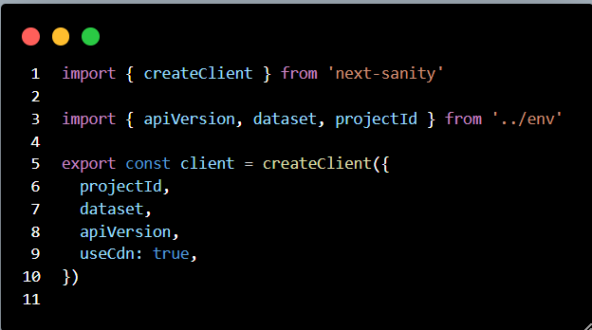
Adjustments in schemas:
Color, Status and Inventory fields updated, as I didn’t add them yesterday but today updated the fields according to provided API
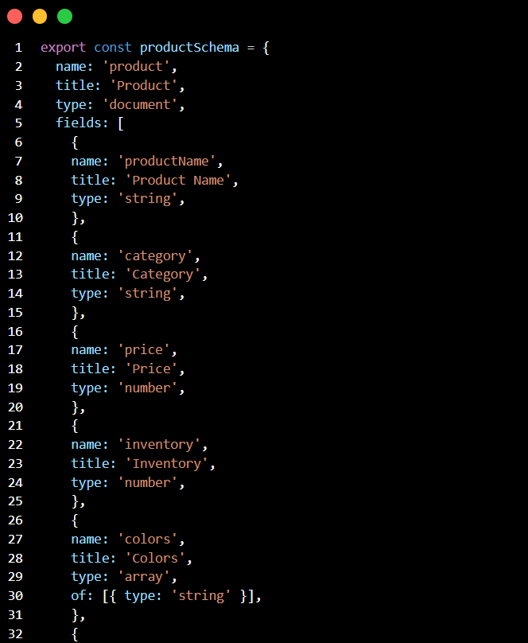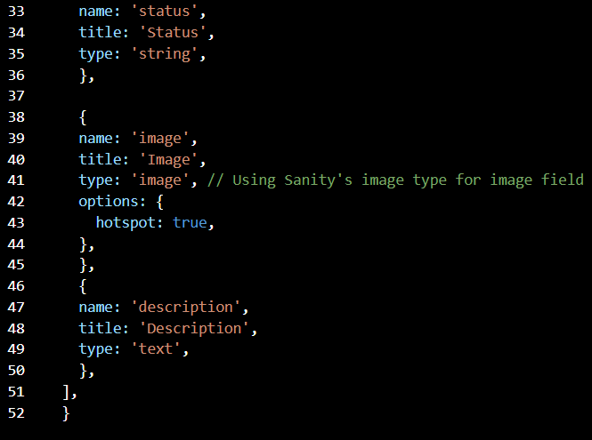
Sanity CMS Fields:
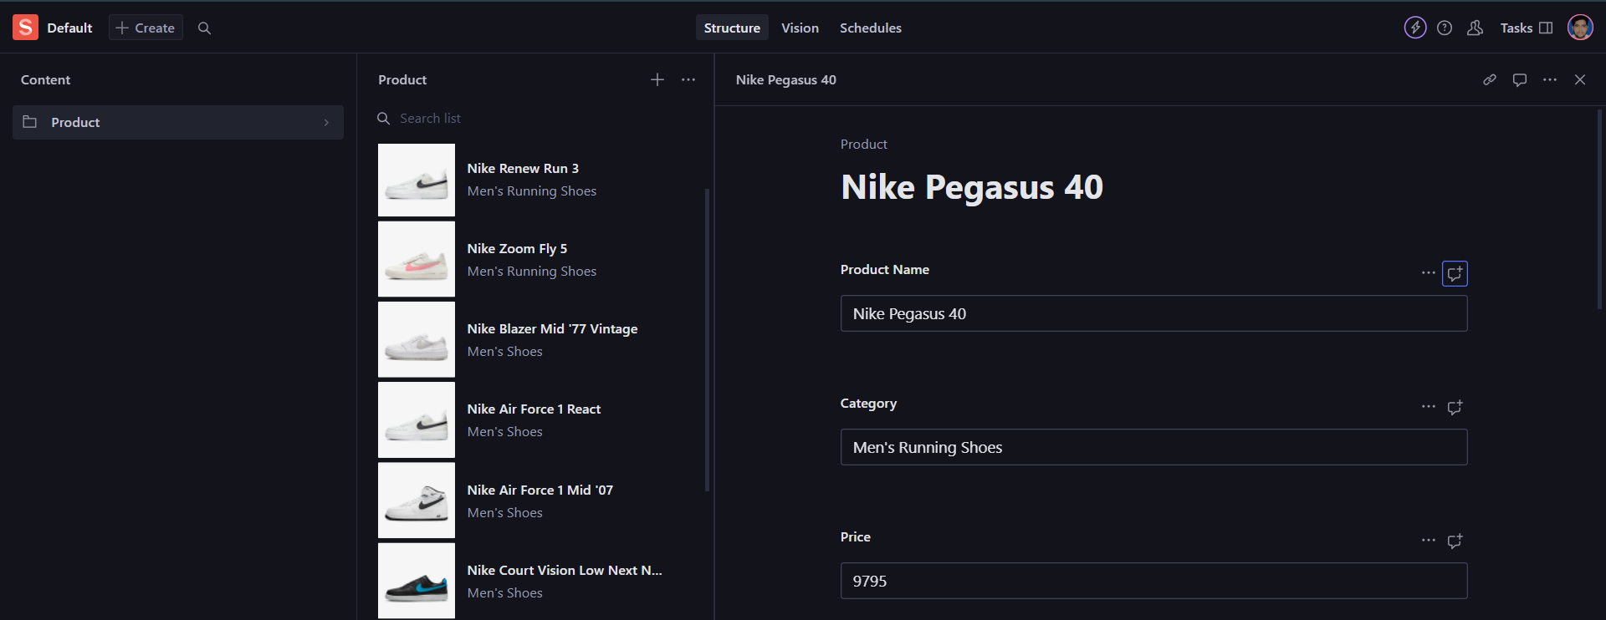

API INTEGRATION PROCESS:
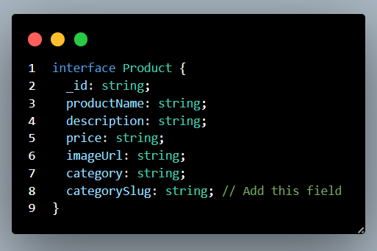
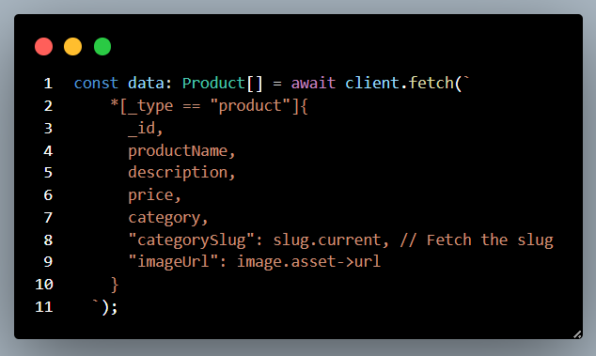
Data Displayed in Front-end:

That’s how I completed Today’s task of Day-03 of Hackathon-03.
Created by WAQAR AHMED
Sunday 2-5 PM.

